Marissa Smith

WRIT 2000

Dr. Kt

Final Project

**ADVERTISEMENT**

Hi there! My name is Marissa, and I would like to invite you to come along on a unique journey with me. A journey to find who you are as a writer! If you choose to follow along, I will take you through my personal writing journey, which will lead you to my *personal* theory of writing. But, remember! You too, have your own theory of writing. And I challenge you find it!

Enjoy!

Xx, Marissa

WHAT

IS

WRITING?

**My Journey, as I know it.**

I have always enjoyed writing because it is my strongest subject. I was never gifted in math or science, but I have always been able to maintain the skills of a strong writer. In elementary school, I would score the highest grades in the class on our writing/English assignments. The learning of grammar, sentence structure, and formatting always came easy to me.

Therefore, I was able to gain immense confidence in myself as a writer from a young age. I knew writing was “my thing.” However, throughout my writing career, I have encountered several challenging obstacles that I have had to work to overcome.

When I was a Junior in high school, my AP English teacher told me I did not have the “talent” I thought I did. As a seventeen-year-old and young adult, I was unsure how-to best handle this situation. My AP English teacher was in a position of power, and she clearly had a lot more writing experience than I had. So, I took what she said to heart. For the remainder of my Junior and Senior years of high school, I lost much of my writing confidence, and I began to dread my English classes because they made me feel anxious.

There was one specific moment during this difficult time for me that stands out. I took the ACT—the standardized test for college admissions, and I achieved a very high score on the English and Writing section. I remember being utterly shocked, because earlier that year my English teacher had explained to me that I was not a good writer, utterly shattering my confidence.

I then had an epiphany. Just because someone, including a teacher or someone of higher power, told me that “I am not a good writer,” does not mean that they are right! I recalled the types of writing I did in that class, and it was all rhetorical analysis on essay prompts the AP foundation would give to us. In other words, the type of writing I did in that class was not writing that I enjoyed.

That was when I realized I ***am***a **good writer**. My **best writing shines through on the work that I am the most passionate about**. That is not to say I enjoy every piece of writing I do! However, some pieces of my writing are better than others, due to the passion I have when I am writing them. The best part of this narrative is I declared myself an English major my Freshman year at DU!

This all leads me to my main point of this personal narrative: **Writing is a beautiful form of art and communication**. Every writer is **unique**. For example, I immeasurably enjoy writing short story mysteries, while someone else may enjoy writing poems. Each individual has their own strengths and weaknesses in the field of writing. **This is what makes the practice of writing so beautiful**. I encourage anyone who has been told they “are not a good writer” of any sort, to persevere like I did. **Keep making art**.

***Now, you are familiar with my personal writing journey and what let me to where I am today. Next, I want to show you the importance of writing, similar to how Didion would show you.***

**To My Blank Sheet of Paper.**

***The Art of Writing***

***By: Marissa Smith***

*Sitting down after a long, busy day.*

*I grab a pen and paper to write my worries away.*

*This gives my mind a chance to relax and reflect,*

*As writing allows my many thoughts to connect.*

*It fills me with joy, and floods me with ease,*

*How is it so fun to articulate what I please?*

*A means of opening up and letting my emotions run free,*

*Who knew the thrill, such an effortless act could be!*

*My most favorite hobby, a true delight,*

*What brings me such happiness—*

*Oh, how I love to write!*

***Without a pen and paper, there is no fluidity. With a pen and paper, there lacks creativity. Writing is not limited to a pen and paper. Let me show you what I mean.***

**Writing leaves many trails…**

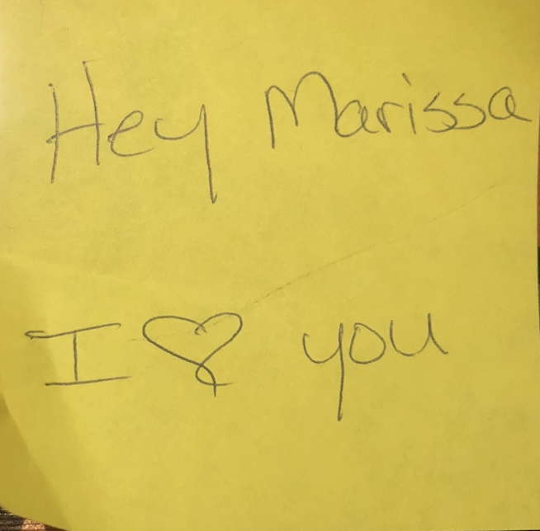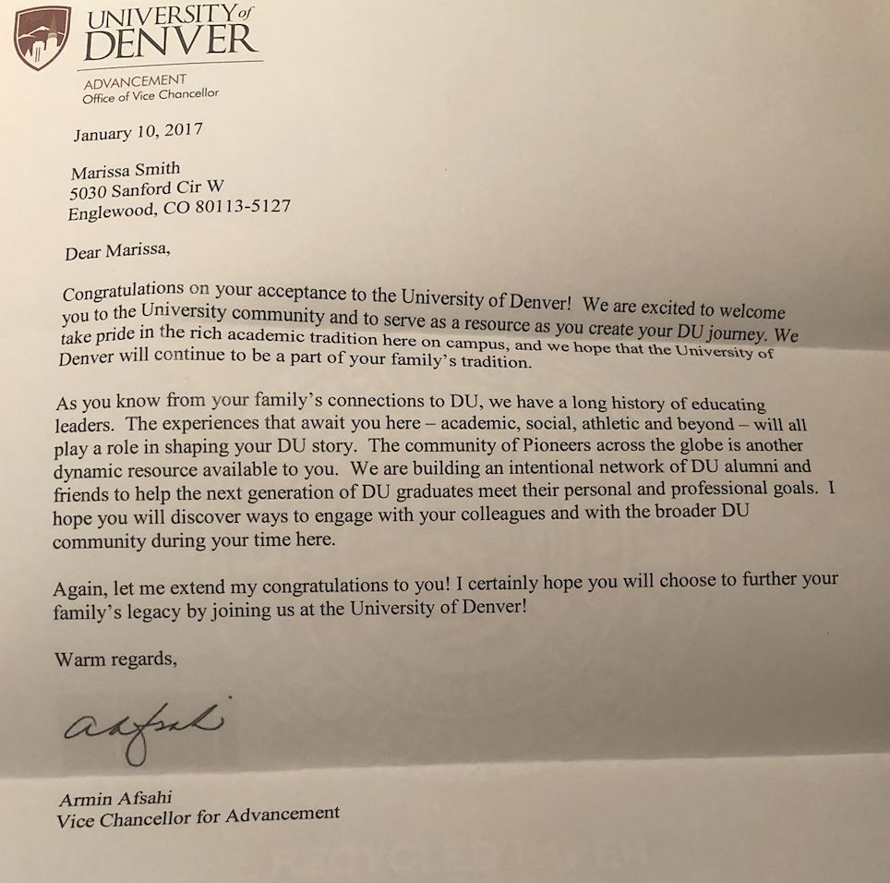

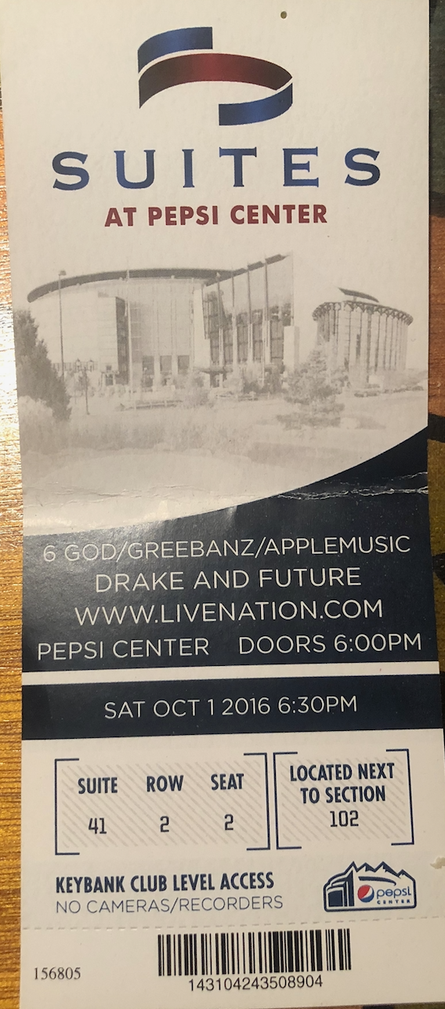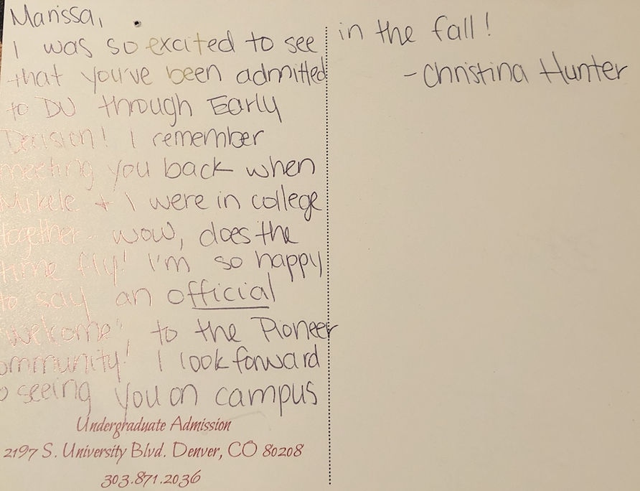

You might ask, “What is the importance of a concert ticket, a sticky note, a letter, or a postcard?”

Well, that concert ticket happens to be the first date I ever went on with my first boyfriend in high school. That sticky note is something my mom left for me when I was having an extremely bad day. That letter was what I received shortly after I had been accepted into the University of Denver, and that postcard was a congratulations from someone who worked in the Admissions office that I was out of touch with for several years.

These various pieces of scrap writing have made an important impact on my life. I saved that concert ticket because it was an experience I will never forget. He was my first boyfriend, and I remember every breath of anxiety I inhaled and exhaled. I remember the butterflies plastered to the pits of my stomach. When I was younger, my mom would leave short little notes in my sack lunches. It would make my whole entire day when she would do this, because if I was having a bad day, her heartfelt notes to me would change my attitude. The letter from the University of Denver still holds a special meaning to me, because I remember receiving it and feeling so grateful and excited. Lastly, the postcard I received was from someone I met at the age of twelve. I ended up losing touch with her until she sent me this postcard. Her small act of kindness with reaching out to congratulate me, after years of not speaking, has restored hope that there are caring and intentional people in this world.

You see, I have held onto these pieces of scrap writing because they mean something important to me. To you, they might mean something totally different. Again, **this is the beauty of writing.**

***Now, I have shown you what writing is through my personal narrative, I have shown you the essence of the pen and paper, and I have shown you one of the most unique forms of writing, and also, my personal favorite—scrap writing. Writing also is not always formal. You process sentences through your thoughts, speech, and everyday communication.***

**Mainstream Communication.**

Hey Marissa! It’s Dr. Kt.

Like, postcards, sticky notes, murals, scrap writing? Well, I feel like I have all of the pieces that make up your theory of writing, but can you make your theory more distinguished?

Yes, I have! I have a couple of questions. So, you’re saying that writing to you is a form of communication, it’s a form of art, and it’s multipurpose?

Hey Dr. Kt! Have you been following along on my Writing Journey?

Yes! And, it is multi-modal. While the pen-to-paper action of writing is traditional and beautiful in itself, it’s debilitating. Writing can take many forms.

***This next section titled, “Final Words.” represents the snap of a camera taking a picture of me in my most natural element. This story acts as the connective tissue, building a bridge that leads to my final thoughts.***

**Final Words.**

Everything was peaceful. I inhaled—deeply, slowly exhaling my breath into the air. The wind chimes were dancing, a slight breeze was in the air. Birds were fluttering around me. Sunflowers were surrounding me all throughout the emerald green field. A butterfly batted its wings towards me, I held out my pointer finger. The blue butterfly gracefully landed on my index finger, I grinned. My heart embraced nature. The butterfly remained perched on my finger for a few moments, almost as if it was catching its breath, taking in all that this beautiful world has to offer.

I reached for my pen and paper and glanced up at the illusory, bright blue sky. White, fluffy clouds were scattered throughout. A hummingbird flew directly above me, casting a warm shadow above my head. I opened up my writing journal and flipped to my journal entry entitled “The Essence of Writing”. I began to press my pen to my paper, and I let my soul pour out.

The essence of writing? The desire to illustrate, the desire to explain. The opportunity to express oneself. When I write, I lose sense of all that is of meaning to me in this world. I am able to focus on writing itself, the art of creativity, self-expression, clarification, imagination, and empathy. Writing is the avenue to improving mental health. It has acted as my friend—sometimes, my only friend. The world I enter when I write is the only world I can trust.

I am a friend. I am a daughter. I am a sister. I am a grandchild. I am a writer. Being a writer is far superior to each of these identities. It opens doors for me, it fosters relationships with other writers, it is a significant part of who I am. Writing can take its form in several different modes of expression. Writing can be multimodal, it can be a speech, it can be anything. This is what makes writing art. Writing can be structured, disoriented, unapologetic, forgiving, or a mixture of these characteristics. It is a unique form of communication. Writing makes our thinking and learning permanent and meaningful. It gives us a voice. A voice to be heard. It presents endless amounts of opportunities—opportunities to inspire, encourage, and teach readers. Writing is a true art that willingly presents itself in shapes of all different forms. It is truly a beacon of light. I encourage you to please,

**Write, write, write.**

**Who am I?**

**Conclusion**

I stare at my reflection in the mirror. Who am I? I am a writer. I have acquired several skills over the course of my academic journey, and this has allowed me to gain confidence as a writer. When I write, I let the words pour out not only from my mind, but also from my body. I listen to the insides of my body. I write to the beat of my heart. I allow myself to fly freely when I write, while also allowing myself to stay structured and organized. My creative genes seep through the tips of my fingers as I type on my keyboard, and my intellectual mindset flows through the tip of my pen onto paper. When I write, I do not have to prove myself to anyone. Writing is a part of me. I glance back at myself in the mirror, and I smile to myself. I am proud of what I have achieved over the past several years as a writer. I reminisce on some of my favorite genres that I have written in—health communication articles, fantasy, mystery, creative non-fiction, creative writing fiction, prose. Every writing experience has helped shaped me into who I am, and *every* writer can attest to this. So, what is writing? I have shown you that it is not just the act of putting a pen to paper, and it is not absent of personal experiences. I have shown you how we use writing in our everyday lives through speech, communication, and even text messages. I have shown you, now let me just tell you, like Ong would.

Writing is the essential form of creative or informative expression. An enjoyable craft, to be honed, over one’s lifetime.